Required Documents

- Last educational certificate
- Transcripts,
- Scan of photograph with white background, 3 cm * 4 cm (For women, hijab is necessary)
- Information pages of the Passport;
- Recommendation Letter (1 for Bachelor's degree for one/two semesters, 2 for Master's degree)
- Latest CV.

- The applicant should scan all the documents above and resend them in qualified, acceptable and readable resolution and size.

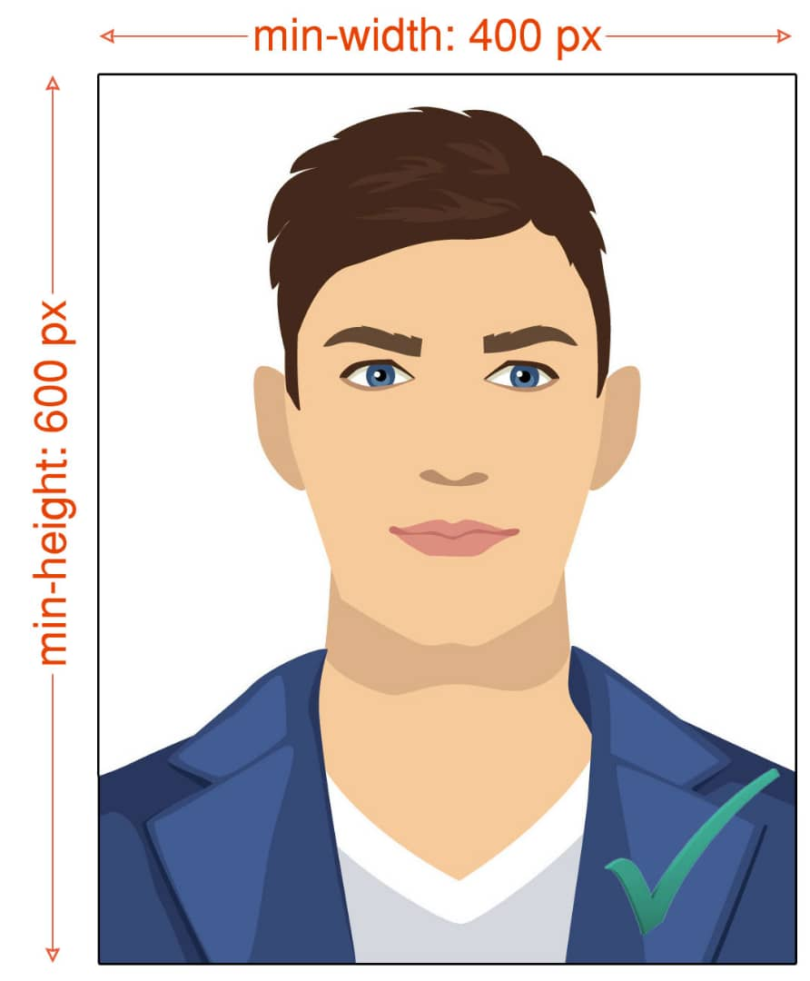
Sample Photo

